Pixel Image Editor

User Guide



P.I.E

Thank you for using our Pixel Image Editor! Click the links below to jump to specific topics or scroll down to learn more about P.I.E.!

Installation

P.I.E is hosted on the docker repository as well as GitHub. P.I.E. Because P.I.E. is an open source program, the raw source code is completely available on GitHub.

GitHub:

To access the raw source code, visit: <https://github.com/FrancescoLimoni/P.I.E>

If you have a GitHub account, you can click the clone button, followed by clone repository to clone the source code to your personal repository.

The source code can also be downloaded as a .zip file view the Clone/Download button followed by download. Zip.

The source code can be run on any IDE and machine that has Ruby installed, as well as the FXRuby, and Launchy Gems. Information on how to download and install ruby and the required gems can be found at these locations:

Ruby: <https://www.ruby-lang.org/en/downloads/>

FXRuby: <https://github.com/larskanis/fxruby>

Launchy: <https://github.com/copiousfreetime/launchy>

Docker:

Docker URL: <https://hub.docker.com/r/obitar/pie-app>

To access the docker container:

* 1. Create an account at <https://hub.docker.com/>.
  2. Verify your email.
  3. Docker Desktop at <https://hub.docker.com/?overlay=onboarding>
  4. Use the Docker Pull command to pull and download the app: docker pull obitar/pie-ap

Startup

After the program launches, you will see the following screen:

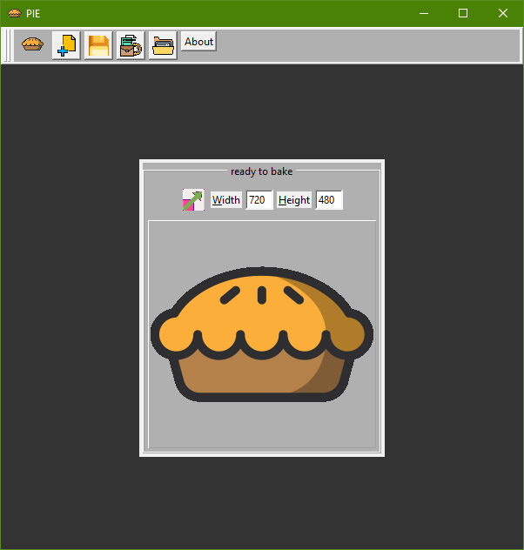

Click the center button to open a new file. Or, click the new file icon on the toolbar to open a new file. Regardless, you will then see the main screen:

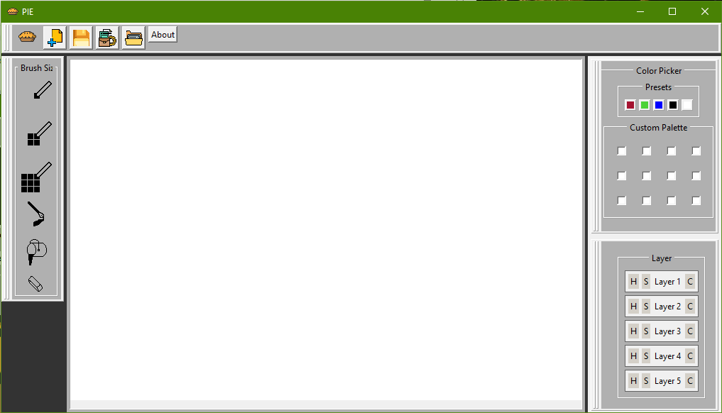

Now you can draw whatever you want!

The Basics

This program can be used to edit an image pixel by pixel or draw more freely. You can customize the position of each panel in the editor by clicking and dragging from the left side of each box. They can be snapped back into place around the screen, or they can float freely on the side- whatever you choose. From the main screen you can choose from a variety of colors and brushes. Choosing custom colors from the Color Panel allows for even more flexibility and expression. You can erase anything you draw by clicking the eraser button. Try playing around with colors and different types of brushes!

The Canvas

The canvas is the part of the program that can be drawn on. After selecting your color and brush size, click and drag on the canvas to draw or click once and release to draw a single pixel.



The canvas is shown above and is initially filled completely white. Below is an example of the kind of masterpieces you can create!

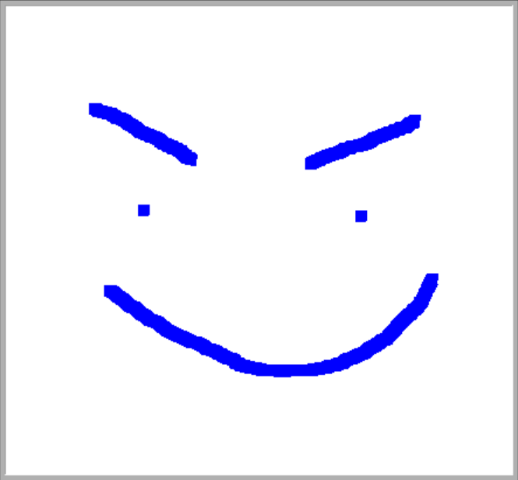

If you resize the program you can hide the canvas, but don't worry it won't erase any of your work!

The Brush Panel

There are three different brush sizes to choose from, 1x1, 2x2, and 3x3.

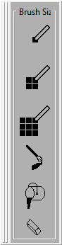

Click on one of the buttons to select your brush type.













The fancy brush draws with a diagonal dimension. The fill pail fills the entire screen a solid color. And the eraser is a larger brush, which only colors white. Below is an example of the fancy brush in different colors.

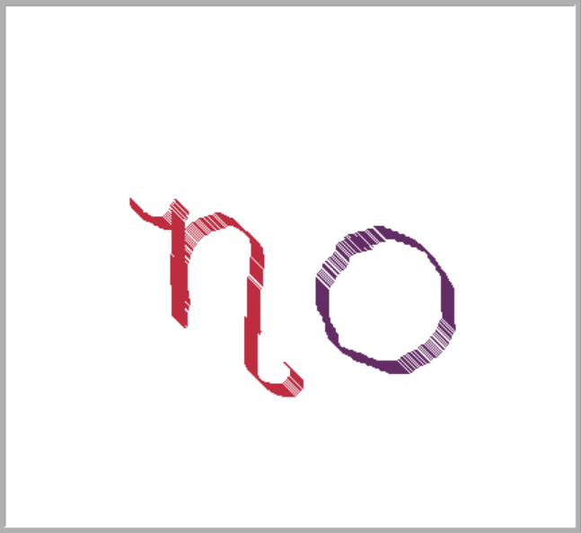

Brush demonstrations are shown below.

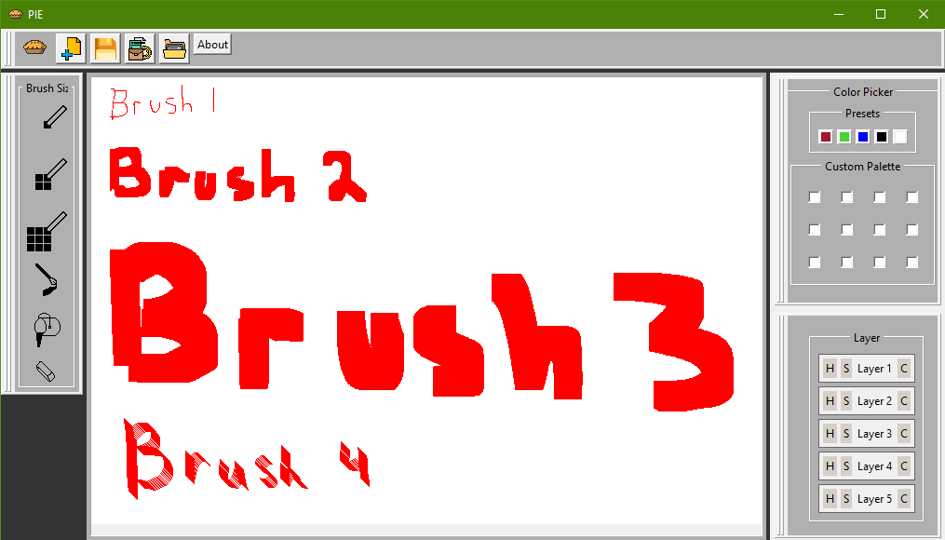

The Color Panel

The color panel is initially to the right of the canvas

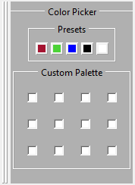

Five colors are pre-set for you to choose from, and the color palette is empty until you assign colors to it. Double click on a box in the Custom Palette section to choose a new color!

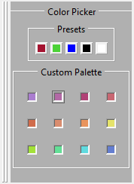

Clicking a blank box in the Custom Palette section opens up a new window where you can choose from many different colors. These options are shown below.

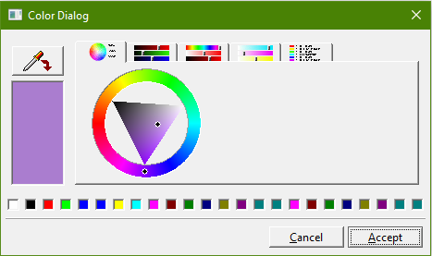

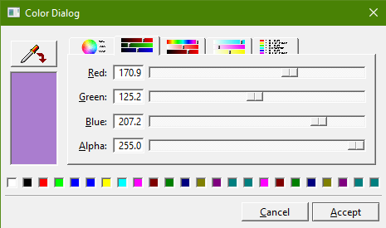

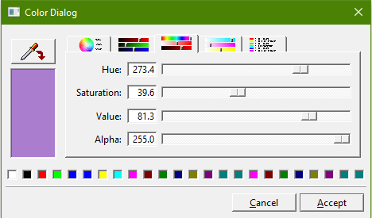

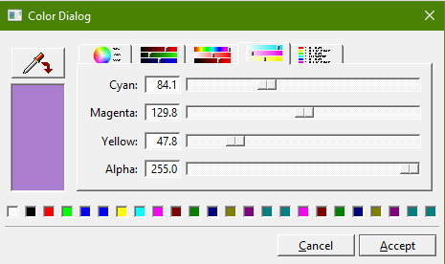

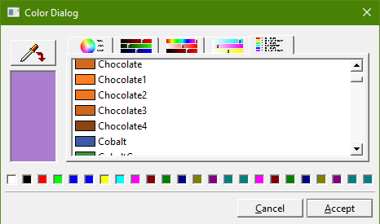

The Layer Panel

The Layer Panel is located at the bottom right of the screen. Use this panel to add or remove layers from your project.

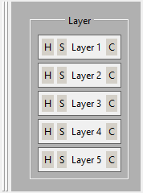

Hide a layer by clicking the H button and select a layer by clicking the S button. Clicking C will clear the contents of the layer.

The Toolbar

The toolbar is located at the top of the screen.

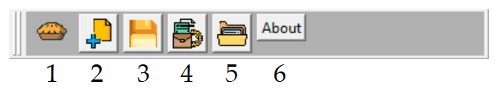

1 - The PIE button

Click this button to access your "New," "Load," "Save," "GitHub," and "Exit" options! The "GitHub" option redirects you to our GitHub page!

2 - New Project

Click this button to create a new PIE project!

3 - Save as PIE file

Click this button to save your image as a PIE file! (This will keep your layers and color options saved)

4 - Export as PNG

Click this button to save your file in PNG format!

5 - Open a PIE Project

Click this button to open one of your previously saved PIE projects!

6 - About

Click this button to navigate to this page! <3